**Exercise 1: Control Structures**

**Scenario 1:** The bank wants to apply a discount to loan interest rates for customers above 60 years old.

* + **Question:** Write a PL/SQL block that loops through all customers, checks their age, and if they are above 60, apply a 1% discount to their current loan interest rates.

**Code :**

BEGIN

FOR loan_rec IN ( SELECT l.loanid, l.interestrate, c.age FROM Loans l JOIN Customers c ON l.loanid = c.customerid )

LOOP

IF loan_rec.age > 60 THEN

UPDATE Loans

SET interestrate = interestrate - 1

WHERE loanid = loan_rec.loanid;

END IF;

END LOOP;

COMMIT;

END;

/

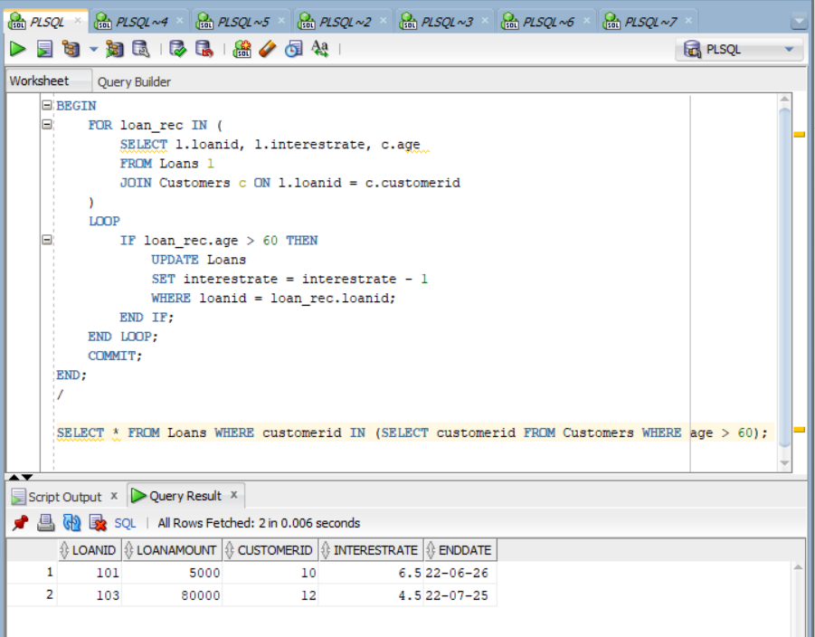**OUTPUT:**

**Scenario 2:** A customer can be promoted to VIP status based on their balance.

* + **Question:** Write a PL/SQL block that iterates through all customers and sets a flag IsVIP to TRUE for those with a balance over $10,000.

**Code :**

BEGIN

FOR cust_rec IN ( SELECT customerid, balance FROM Customers)

LOOP

IF cust_rec.balance > 10000 THEN

UPDATE Customers

SET is_vip = 'Y'

WHERE customerid = cust_rec.customerid;

END IF;

END LOOP;

COMMIT;

END;

/

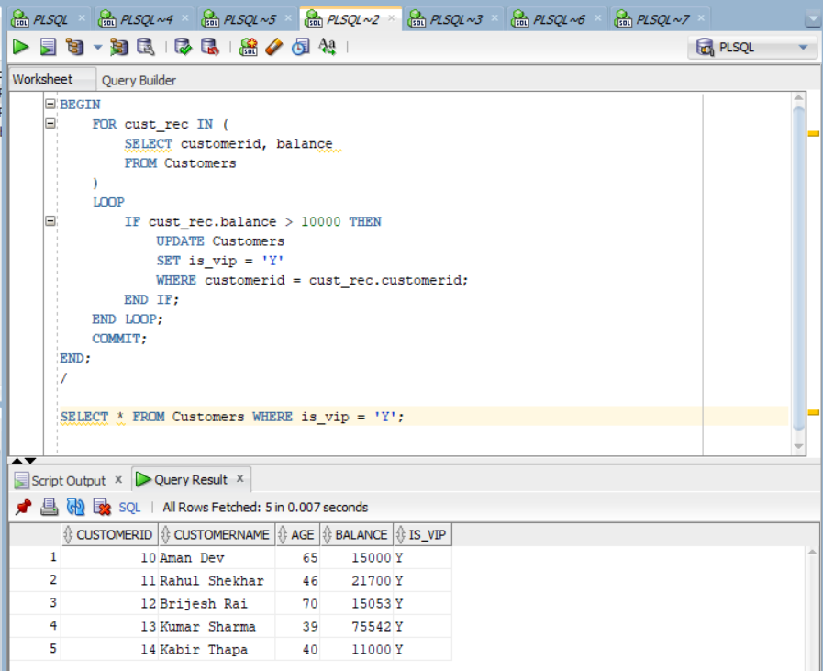 **OUTPUT:**

**Scenario 3:** The bank wants to send reminders to customers whose loans are due within the next 30 days.

**Question:** Write a PL/SQL block that fetches all loans due in the next 30 days and prints a reminder message for each customer

**Code:**BEGIN

FOR loan_rec IN ( SELECT l.loanid, c.customername, l.enddate FROM Loans l JOIN Customers c ON l.customerid = c.customerid WHERE l.enddate BETWEEN SYSDATE AND SYSDATE + 30 )

LOOP

DBMS_OUTPUT.PUT_LINE('Reminder: Loan ' || loan_rec.loanid ||

' for customer ' || loan_rec.customername ||

' is due on ' || TO_CHAR(loan_rec.enddate, 'DD-MON-YYYY'));

END LOOP;

END;

/

**OUTPUT:**

